CHENNAI INSTITUTE OF TECHNOLOGY

DEPARTMENT OF COMPUTER SCIENCE AND ENGINEERING

PROJECT-BASED LEARNING (PBL) REPORT
EMBEDDED PROGRAMMING (CS4502)

IoT-Based Water Quality Monitoring System Using Arduino UNO and Analog Turbidity Sensor
Submitted in partial fulfilment of the requirements for the
Project-Based Learning component of Embedded Programming

Submitted by
Harshini T V (24CS0316)
Harini R (24CS0298)

Under the guidance of
Mr. K. Madhavan
[Designation, Department of CSE]


September, 2026
BONAFIDE CERTIFICATE

This is to certify that the Project–Based Learning report titled “IoT-Based Water Quality Monitoring System Using Arduino UNO and Analog Turbidity Sensor” is a Bonafide record of work carried out by Harshini T V (24CS0316) and Harini R (24CS0298) of the Department of Computer Science and Engineering, Chennai Institute of Technology, in partial fulfilment of the Project-Based Learning component of Embedded Programming (CS4502) during the academic year 2026–2027.

Faculty Mentor Head of Department
Date:

Submitted for the PBL evaluation held on [date].
Faculty Mentor: Mr. K. Madhavan PBL In-charge: Mr. Muthupandi G
DECLARATION
We declare that this Project-Based Learning report titled “IoT-Based Water Quality Monitoring System Using Arduino UNO and Analog Turbidity Sensor” reflects our own work carried out under the guidance of Mr. K. Madhavan across the PBL review cycle. All sources of information used have been duly acknowledged and cited in the references.

Team Members:
Harshini T V, 24CS0316, Signature: __________

Harini R, 24CS0298, Signature: __________

PBL COURSE AND TEAM DETAILS

Field | Details
Course | Embedded Programming (CS4502) — Project-Based Learning (PBL)
Faculty Mentor | Mr. K. Madhavan, Class Subject Faculty
PBL In-charge | Mr. Muthupandi G
Section / Team No. | CSE — E, Team [No.]
PBL Duration | 12 weeks (Week 1 – Week 12)
Review Cycles Completed | Review I: 23.06.2026 | Review II: 25.07.2026 | Review III: 12.08.2026 to 14.08.2026
Project Track / Domain | Environmental Monitoring / Water Quality (IoT)

Team Roles and Responsibilities
Name | Register No. | Role | Primary Responsibility
Harshini T V | 24CS0316 | Hardware & Firmware Lead | Circuit assembly, sensor interfacing, Embedded C firmware, calibration testing
Harini R | 24CS0298 | Documentation & Research Lead | Report writing, block/circuit diagrams, literature survey, results analysis

ACKNOWLEDGEMENT

We would like to thank Mr. K. Madhavan, [Designation], Department of Computer Science and Engineering, for guiding this project through every review cycle. The feedback we received after each review shaped how we approached the hardware assembly and, in particular, pushed us to properly investigate the sensor calibration mismatch instead of ignoring it. We are also grateful to [HOD Name], Head of the Department, for providing the lab facilities and the PBL structure that allowed us to build and test the prototype in stages rather than rushing a single final version. Finally, we thank our classmates who helped us troubleshoot the initial upload errors during assembly.

ABSTRACT

Access to safe drinking water is a basic requirement, but most households have no quick way of checking whether their water has become contaminated. Turbidity — the cloudiness caused by suspended particles such as silt, clay and organic matter — is one of the most widely used indicators of water quality, and a sudden rise in it is often the first sign that something has gone wrong with a water source. This project presents a low-cost, standalone embedded system that continuously measures water turbidity using an analog turbidity sensor interfaced with an Arduino UNO, and reports the result in real time on a 16×2 I2C LCD as well as the Arduino IDE Serial Monitor. The firmware reads the sensor's analog output, converts it into an approximate Nephelometric Turbidity Unit (NTU) value using a second-order calibration equation, and compares it against a configurable safety threshold to classify the sample as “Water Safe” or “Water Unsafe”. The complete prototype was assembled, housed in a compact enclosure, and tested with real tap water samples. During testing we encountered a genuine calibration mismatch — the sensor's clear-water voltage measured 1.69–1.80 V against a reference curve assuming roughly 4 V — and this report documents how the fault was isolated to unit-level sensor variation rather than wiring or firmware. The complete system costs under ₹1,600, making it practical for household and small-community use.
Keywords: Arduino UNO, Turbidity Sensor, Water Quality Monitoring, Embedded C, NTU

TABLE OF CONTENTS

TITLE |  | PAGE NO
TEAM AND ROLE RESPONSIBILITIES |  | iv
ABSTRACT AND KEYWORDS |  | vi
LIST OF TABLES |  | xi
LIST OF FIGURES |  | xi
LIST OF ABBREVIATIONS |  | xi
CHAPTER 1 | INTRODUCTION | 1
CHAPTER 1 | - Project Overview | 1
CHAPTER 1 | 1.2 Problem Statement | 1
CHAPTER 1 | 1.3 Objectives | 1
CHAPTER 1 | 1.4 Scope of the Project | 2
CHAPTER 2 | LITERATURE SURVEY | 3
CHAPTER 2 | 2.1 Related Existing Projects | 3
CHAPTER 2 | 2.2 Review of Existing Technologies | 3
CHAPTER 2 | 2.3 Comparison of Existing Systems | 4
CHAPTER 3 | EXISTING SYSTEM | 5
CHAPTER 3 | 3.1 Description | 5
CHAPTER 3 | 3.2 Drawbacks and Limitations | 5
CHAPTER 4 | PROPOSED SYSTEM | 6
CHAPTER 4 | 4.1 Proposed Solution | 6
CHAPTER 4 | 4.2 Features | 6
CHAPTER 4 | 4.3 Advantages | 7
CHAPTER 5 | SYSTEM DESIGN | 8
CHAPTER 5 | 5.1 Block Diagram | 8
CHAPTER 5 | 5.1.1 Physical Design | 8
CHAPTER 5 | 5.1.2 Logical Design | 9
 | 5.2 Working Principle | 9
 | 5.3 Circuit Diagram | 10
 | 5.4 Flowchart | 11
CHAPTER 6 | HARDWARE COMPONENTS | 12
CHAPTER 6 | 6.1 Microcontroller / Development Board | 12
CHAPTER 6 | 6.2 Sensors | 13
CHAPTER 6 | 6.3 Actuators | 14
CHAPTER 6 | 6.4 Display / Output Devices | 14
CHAPTER 6 | 6.5 Communication Module | 14
 | 6.6 Power Supply | 14
 | 6.7 Other Components | 14
CHAPTER 7 | SOFTWARE IMPLEMENTATION | 15
CHAPTER 7 | 7.1 Software Requirements | 15
CHAPTER 7 | 7.2 Embedded C Program | 15
CHAPTER 7 | 7.3 Python Program | 16
CHAPTER 7 | 7.4 Simulation – Wokwi / Raspberry Pi / Thonny (if applicable) | 16
CHAPTER 8 | HARDWARE IMPLEMENTATION | 17
CHAPTER 8 | 8.1 Circuit Assembly | 17
CHAPTER 8 | 8.2 Hardware Connections | 17
CHAPTER 8 | 8.3 Prototype Development | 18
CHAPTER 8 | 8.4 Working of the Hardware Model | 19
CHAPTER 8 | 8.5 Photographs of the Developed Model | 19
CHAPTER 9 | TESTING AND RESULTS | 20
CHAPTER 9 | 9.1 Testing Procedure | 20
CHAPTER 9 | 9.2 Test Cases | 20
CHAPTER 9 | 9.3 Experimental Results | 20
CHAPTER 9 | 9.4 Output Screenshot | 21
CHAPTER 9 | 9.5 Performance Analysis | 22
CHAPTER 10 | APPLICATIONS | 23
CHAPTER 11 | ADVANTAGES AND LIMITATIONS | 24
CHAPTER 12 | CONCLUSION AND FUTURE SCOPE | 25
CHAPTER 13 | REFERENCES | 26
CHAPTER 14 | APPENDIX | 27
 | 14.1 Source Code | 27
 | 14.2 Circuit Diagram | 28
 | 14.3 Component Datasheets | 28
 | 14.4 Additional Photographs | 28
LIST OF FIGURES
FIGURE NO | FIGURE NAME | PAGE NO
Figure 5.1 | Block Diagram | 8
Figure 5.1.1 | Physical Design | 8
Figure 5.1.2 | Logical Design | 9
Figure 5.3 | Circuit Diagram | 10
Figure 5.4 | Flowchart | 11
Figure 6.1 | Microcontroller / Development Board :Arduino chip or esp (if applicable) | 12
Figure 7.4 | Simulation – Wokwi / Raspberry Pi / Thonny (if applicable) | 16
Figure 8.3 | Screen shot of Prototype Development | 18
Figure 8.5 | Photographs of the Developed Model | 19
Figure 9.4 | Output Screenshot | 21

TABLENO | TABLE NAME | PAGE NO
Table 2.3 | Comparison of Existing Systems | 4
Table 3.1 | Weekly PBL progress log | vii
Figure 6.1 | Hardware Components | 12
Figure 7.1 | Software Requirements | 15
Figure 9.3 | Experimental result comparision | 20
Figure 9.4 | Output Screenshot | 21
Figure 9.5 | Performance Analysis | 22
LIST OF TABLES

LIST OF ABBREVIATIONS
ADC — ANALOG TO DIGITAL CONVERTER NTU — NEPHELOMETRIC TURBIDITY UNIT LCD — LIQUID CRYSTAL DISPLAY I2C — INTER-INTEGRATED CIRCUIT IoT — INTERNET OF THINGS PBL — PROJECT-BASED LEARNING IDE — INTEGRATED DEVELOPMENT ENVIRONMENT IR — INFRARED BOM — BILL OF MATERIALS
CHAPTER 1

INTRODUCTION

1.1 Project Overview
Clean drinking water is essential for health, yet laboratory testing of water quality is slow, expensive, and out of reach for most individual households and small rural communities. This project builds a compact, self-contained embedded system that measures water turbidity in real time and immediately reports whether a water sample is likely safe, without needing laboratory equipment or an internet connection. The system uses low-cost, widely available components: an Arduino UNO development board, an analog turbidity sensor module, and a 16×2 I2C LCD. The Arduino continuously samples the sensor's analog output, converts the raw ADC reading into a voltage, applies a calibration equation to estimate turbidity in NTU, and displays both the numeric value and a plain “Water Safe” / “Water Unsafe” verdict on the LCD and Serial Monitor.

1.2 Problem Statement
Many households in semi-urban and rural areas depend on borewells, open wells, or stored tanks with no continuous way of verifying that the water remains safe. Turbidity can rise from sediment disturbance, contamination during storage, biological growth, or degrading pipes and tanks — and by the time the cloudiness is obvious to the naked eye, the water may already pose a health risk. Manual visual inspection is subjective and unreliable, while laboratory testing introduces a delay of days and a recurring cost per test. There is a clear need for an inexpensive, always-on device that monitors turbidity continuously and gives an immediate, easy-to-understand safety indication that anyone can interpret without training.

1.3 Objectives
The specific objectives of this project are:
• To design and implement a low-cost embedded system that measures water turbidity using an analog sensor interfaced with an Arduino UNO.
• To convert raw analog sensor readings into an approximate NTU value using a calibrated mathematical equation.
• To provide a simple, human-readable real-time output (“Water Safe” / “Water Unsafe”) on a 16×2 LCD as well as the Serial Monitor for logging.
• To assemble and test a working hardware prototype using real water samples, and document the complete design and testing process.
• To identify and document the practical calibration challenges of using low-cost analog turbidity sensors, and propose directions for improvement.

1.4 Scope of the Project
This project is limited to a single-parameter (turbidity-only) monitoring prototype built on the Arduino UNO platform. The system operates standalone using a wired USB connection for power and serial monitoring; it does not include wireless connectivity (Wi-Fi/Bluetooth/GSM), cloud logging, or a mobile application, though these are identified as future extensions in Chapter 12. The work covers hardware selection and assembly, firmware development in Embedded C using the Arduino IDE, sensor signal conditioning and calibration, and functional testing with real water samples. The intended users are households, small community water points, and students using the device as a teaching aid; it is not intended to replace certified regulatory water testing, which requires laboratory-grade instrumentation.

CHAPTER 2

LITERATURE SURVEY

2.1 Related Existing Projects
Several open-source and academic projects have explored low-cost water quality monitoring using Arduino and ESP32 platforms. A common approach pairs an analog turbidity sensor with a microcontroller's ADC and estimates NTU using a manufacturer-supplied calibration curve. Kori and Rajashekarappa [1] measured turbidity by tracking how much light is scattered or blocked by suspended particles, establishing the optical principle this project also relies on. Bankar et al. [2] extended this into an Arduino UNO system that sorts water into four bands — clean, slightly dirty, cloudy, and heavily contaminated — using standard NTU cutoffs. Ramadhan, Hidayat et al. [3] built a turbidity meter around an infrared LED and phototransistor pair driven by an Arduino UNO with an LCD readout, demonstrating that this exact low-cost hardware combination gives consistent readings.

2.2 Review of Existing Technologies
Existing turbidity measurement technologies fall into three categories. Laboratory nephelometers are highly accurate calibrated instruments measuring scattered light at a fixed angle per standardized methods such as EPA Method 180.1, but they are expensive, bulky, and require trained operators. Portable handheld meters offer a middle ground — reasonably accurate and field-usable, but still costly for household use and not designed for unattended continuous monitoring. Low-cost analog sensor modules, such as the one used here, are inexpensive and easy to interface with common microcontrollers, at the cost of reduced absolute accuracy. Their output is a simple analog voltage requiring a calibration equation, and as our own testing revealed, this voltage-to-NTU relationship varies noticeably between individual sensor units — making on-site calibration a practical necessity rather than an optional refinement.

2.3 Comparison of Existing Systems
Table 2.3 compares the three categories of turbidity measurement systems reviewed above against the system proposed in this project.
Table 2.3 — Comparison of Existing Systems
The proposed system's advantage in Table 2.3 is concentrated in exactly the row that existing options handle worst: continuous monitoring. Laboratory nephelometers and portable meters both require a person to actively initiate every single measurement, which in practice means testing happens rarely — often only when a problem is already suspected. The system built in this project instead samples automatically every two seconds for as long as it is powered, so a gradual rise in turbidity is far more likely to be caught close to when it begins rather than days or weeks later.
The trade-off is equally visible in the accuracy row. A laboratory nephelometer's “Very High” accuracy comes from controlled optical geometry and factory calibration traceable to a certified standard, neither of which a ₹300 sensor module can match out of the box. The “Moderate (needs calibration)” rating recorded here is therefore not a design flaw so much as an honest acknowledgement of where this class of hardware sits — acceptable for a screening decision, but not a substitute for a certified water-quality certificate.
Parameter | Lab Nephelometer | Portable Meter | Proposed System
Approx. Cost | ₹50,000+ | ₹5,000–20,000 | ₹960–1,600
Accuracy | Very High | High | Moderate (needs calibration)
Portability | Low | High | High
Continuous Monitoring | No | No | Yes (every 2 s)
Operator Skill | High | Moderate | Low (auto verdict)
Household Suitable | No | Limited | Yes

CHAPTER 3

EXISTING SYSTEM

3.1 Description
In most households today, water quality is assessed either through infrequent manual sampling followed by laboratory testing, or far more commonly through simple visual inspection — checking whether the water looks clear and smells normal. Where laboratory testing is used, samples are collected, transported to a certified facility, and analyzed using standardized nephelometric methods, with results typically available only after several hours to several days and a fee per test. A smaller number of users own portable digital turbidity meters, which give an immediate on-site reading but require the user to actively operate the device on demand. In neither case does the existing approach provide continuous, automated, real-time feedback without repeated human intervention.

3.2 Drawbacks and Limitations
The key drawbacks of the existing approaches are:
• Laboratory testing introduces a delay of days between sampling and results, during which contaminated water may already have been consumed.
• Manual visual inspection is highly subjective — turbidity well above safe limits can still appear clear to the untrained eye.
• Portable handheld meters require the user to remember to test manually and provide no continuous or unattended monitoring.
• Both laboratory testing and portable meters involve a recurring cost per test, making frequent monitoring economically impractical.
• No existing common approach integrates an automatic, always-on safety verdict that a non-technical household member can interpret instantly without training.

CHAPTER 4

PROPOSED SYSTEM

4.1 Proposed Solution
The proposed system is a self-contained, low-cost device that continuously monitors water turbidity and gives an immediate, automatic safety verdict, eliminating the delay, cost, and subjectivity of existing approaches. An Arduino UNO is interfaced with an analog turbidity sensor whose output voltage is continuously sampled and converted into an estimated NTU value. This value is compared against a configurable safety threshold (set to 50 NTU in the current implementation, based on commonly referenced drinking-water guidance), and the corresponding “Water Safe” or “Water Unsafe” status is displayed on the LCD and printed to the Serial Monitor. The architecture was deliberately kept as simple as possible — one microcontroller, one sensor, one display — to maximize reliability, minimize failure points, and keep the total cost low.

4.2 Features
The main features of the proposed system are:
• Continuous automatic measurement every two seconds, requiring no manual operation once the probe is placed in the sample.
• Real-time numeric NTU display alongside an unambiguous “Water Safe” / “Water Unsafe” verdict on the LCD.
• Configurable safety threshold defined in software, allowing sensitivity to be adjusted for different use cases.
• Serial Monitor output of every reading (raw ADC value, voltage, NTU) for logging, debugging, and calibration analysis.
• Compact, portable hardware built from low-cost components, housed in a small enclosure for practical field use.

4.3 Advantages
The advantages of this approach are:
• Total prototype cost under ₹1,600 — a small fraction of the cost of even entry-level portable turbidity meters.
• Immediate result with no waiting for laboratory transport or analysis; the verdict updates automatically every two seconds.
• No specialized training required — the LCD states the verdict directly rather than showing a raw number needing interpretation.
• Open, modular design that can be extended with additional sensors or wireless connectivity without redesigning the core system.
• Serves as an accessible educational platform for teaching embedded systems, sensor interfacing, and environmental monitoring.
Taken together, these advantages address the specific gap identified in Chapter 3. Laboratory testing is accurate but slow and expensive; visual inspection is instant and free but unreliable. This system occupies the middle ground that neither currently covers — it is fast and cheap like visual inspection, but it applies a fixed numerical criterion rather than depending on the user's judgement, and it does so continuously rather than only when someone remembers to look.
It is equally important to be clear about what the design does not claim. The system reports turbidity only, so a sample that is chemically or microbiologically contaminated while remaining optically clear will still be reported as safe. The verdict should therefore be read as “no visible particulate contamination detected” rather than as a guarantee of potability. This limitation is revisited in Chapter 11 and shapes the multi-sensor direction proposed in Chapter 12.

CHAPTER 5

SYSTEM DESIGN

5.1 Block Diagram
Figure 5.1 shows the overall system block diagram. The Arduino UNO forms the central processing unit: it receives 5V power over USB, reads the analog voltage produced by the turbidity sensor immersed in the water sample, computes the corresponding NTU value in firmware, and drives two output channels simultaneously — the 16×2 I2C LCD for local display, and the Serial Monitor on the connected PC for logging and debugging.
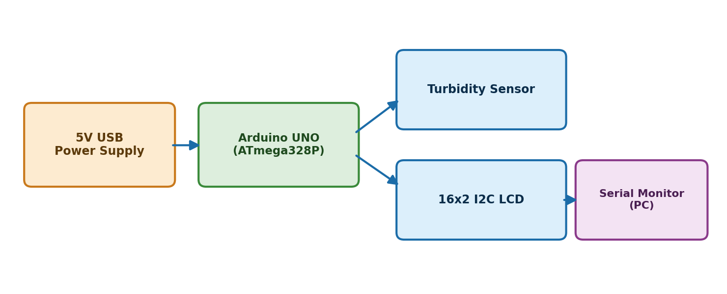
Figure 5.1 — System Block Diagram

5.1.1 Physical Design
Figure 5.1.1 shows the physical design, identifying the actual devices in the system and how they are physically connected. The water sample is the input to the sensor probe, which passes its conditioned analog signal to the Arduino's A0 pin; the Arduino in turn drives the LCD, with the whole assembly powered from a 5V USB supply.
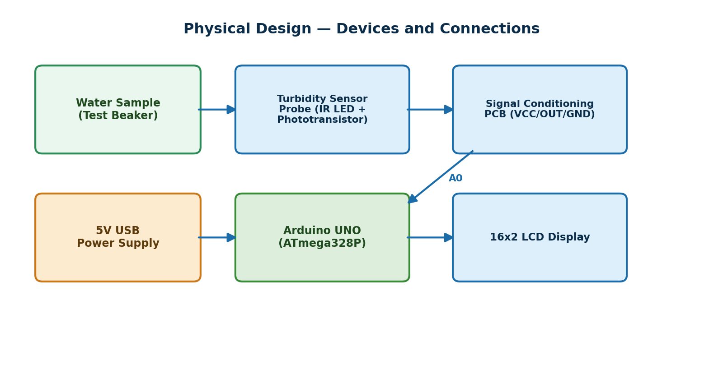
Figure 5.1.1 — Physical Design

5.1.2 Logical Design
Figure 5.1.2 shows the logical design as a sequence of processing layers. The analog sensing layer feeds the acquisition layer (the 10-bit ADC), whose digital output passes to the processing layer where the calibration equation is applied. The decision layer compares the computed NTU against the safety threshold, and the presentation layer renders the result to the LCD and Serial Monitor.
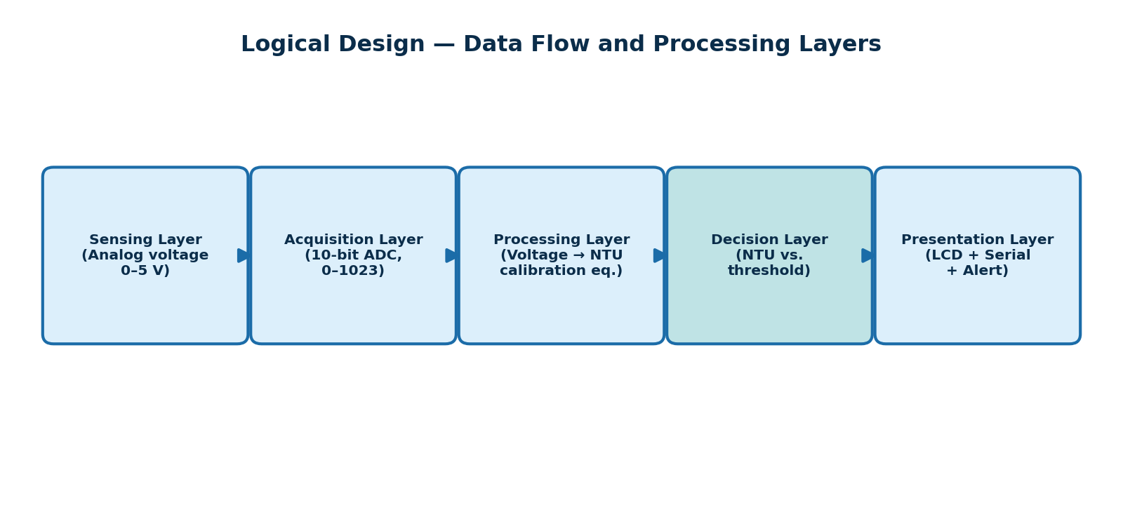
Figure 5.1.2 — Logical Design

5.2 Working Principle
The turbidity sensor operates on the principle of infrared light scattering. An internal infrared LED emits light into the water sample, and a phototransistor positioned at a fixed angle measures the intensity of light reaching it after passing through the water. Clear water allows most light to pass directly to the receiver with little scattering, while suspended particles scatter more of the light, reducing the intensity reaching the receiver. The sensor module converts this intensity into an analog output voltage in the 0–5 V range. The Arduino's 10-bit ADC samples this voltage on pin A0, producing a digital value between 0 and 1023. This raw value is converted back to a voltage using Voltage = ADC_Value × (5.0 / 1023.0), and the voltage is passed through a second-order polynomial calibration equation to estimate turbidity in NTU. The computed NTU is compared against the 50 NTU threshold; exceeding it reports “Water Unsafe”, otherwise “Water Safe”. This read–compute–display cycle repeats every two seconds.

5.3 Circuit Diagram
Figure 5.3 shows the wiring diagram interconnecting the Arduino UNO, turbidity sensor module, and LCD. The sensor's three pins (VCC, OUT, GND) connect to the Arduino's 5V, A0, and GND respectively. The LCD communicates over I2C using two signal lines (SDA, SCL) in addition to power and ground, connecting to the Arduino's dedicated I2C pins A4 and A5.
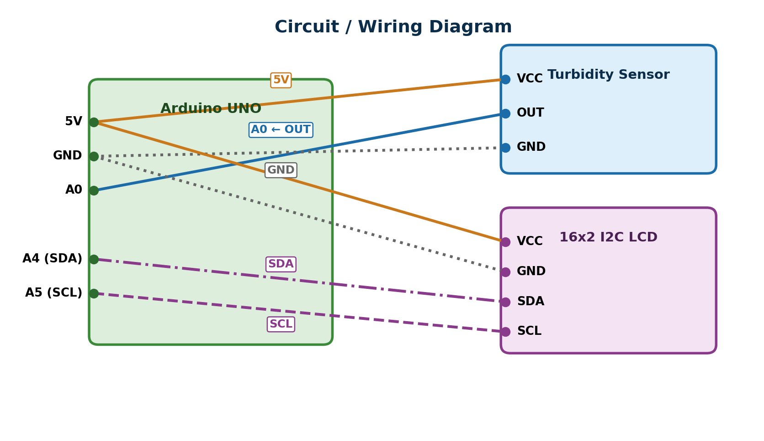
Figure 5.3 — Circuit / Wiring Diagram

5.4 Flowchart
Figure 5.4 illustrates the firmware flowchart. After initializing the LCD and Serial communication, the system enters a continuous loop: read the sensor, convert to voltage and NTU, clamp any negative NTU to zero, compare against the threshold, display the corresponding verdict, wait two seconds, and repeat indefinitely.
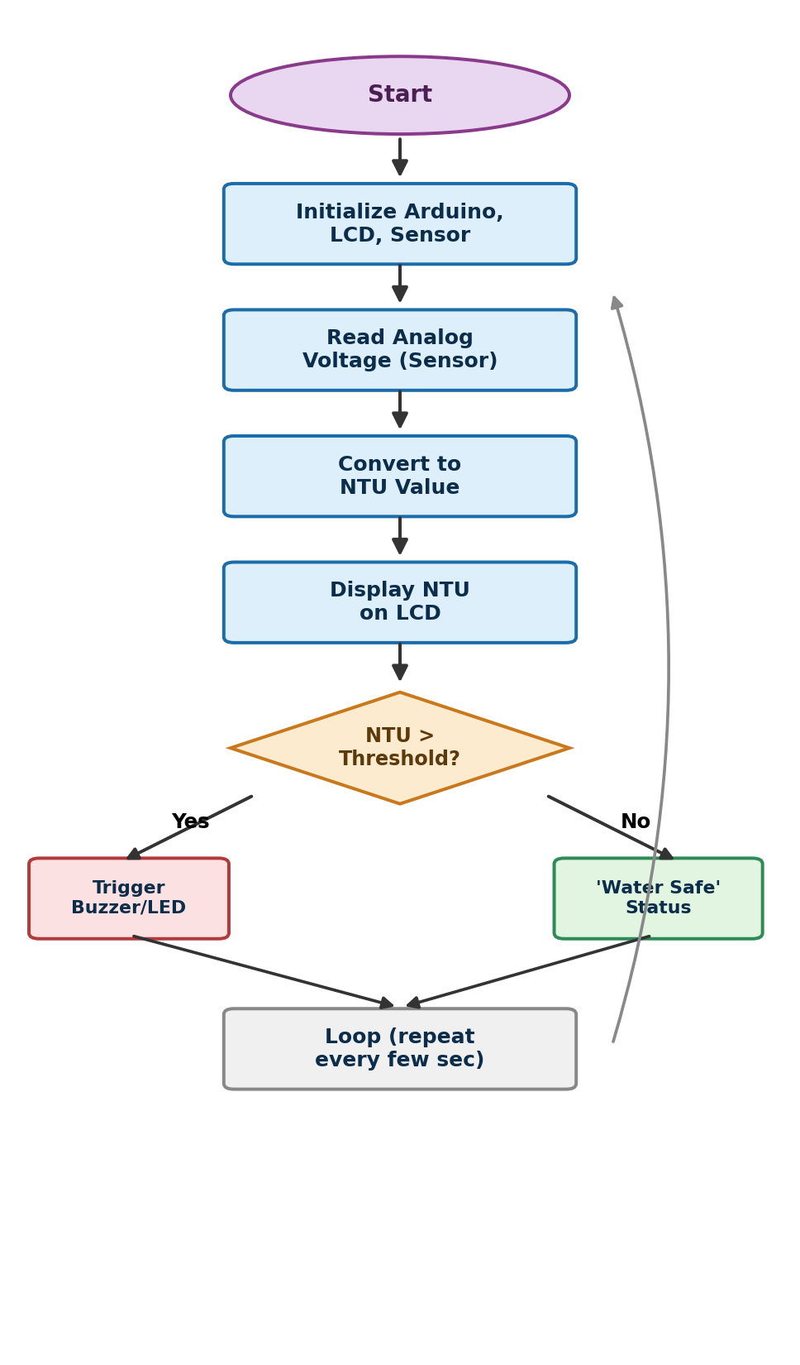
Figure 5.4 — Firmware Flowchart
Three design decisions in this flow are worth noting. First, the negative-NTU clamp exists because the calibration equation is a parabola: at very low and very high voltages it returns negative values that have no physical meaning, so the firmware floors the result at zero rather than displaying a nonsensical reading. Second, the two-second delay is a deliberate compromise — fast enough that the display tracks a changing sample almost immediately, but slow enough that the LCD text is readable and does not flicker between updates. Third, the safety threshold is stored as a single named constant (thresholdNTU) rather than being written into the comparison directly, so the sensitivity of the Safe/Unsafe decision can be re-tuned after calibration without touching any other part of the program.
The loop deliberately has no exit condition. Once powered, the device runs this cycle indefinitely, which matches the intended use case: the system is meant to sit with its probe in a water source and keep reporting, not to take a single measurement on command and stop.

CHAPTER 6

HARDWARE COMPONENTS

6.1 Microcontroller / Development Board
The Arduino UNO, based on the Microchip ATmega328P 8-bit microcontroller, is the central processing and control unit of this project. It was selected for its wide availability, extensive community support, a large library ecosystem including ready-made I2C LCD libraries, sufficient analog input pins, and low cost. Figure 6.1 identifies the specific pins used in this project.
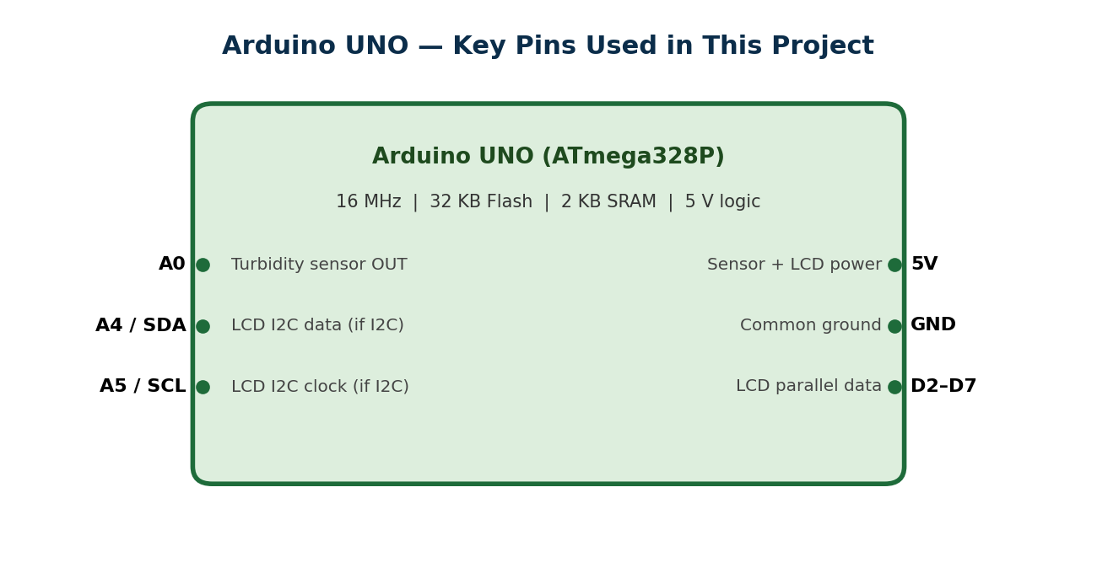
Figure 6.1 — Arduino UNO Development Board and Pins Used
Table 6.1 — Hardware Components: Arduino UNO Specifications
Specification | Value
Microcontroller | ATmega328P
Operating Voltage | 5 V
Digital I/O Pins | 14 (6 PWM)
Analog Input Pins | 6 (A0–A5)
Clock Speed | 16 MHz
Flash Memory | 32 KB (0.5 KB bootloader)
SRAM | 2 KB

6.2 Sensors
An analog turbidity sensor module is the primary sensing element. It consists of an infrared LED emitter and a phototransistor receiver mounted in a sealed probe housing suitable for direct immersion in water up to its rated waterproof line, connected via a short cable to a small signal-conditioning PCB exposing three pins: VCC (power), GND (ground), and OUT (analog signal output, 0–5 V, inversely related to suspended-particle concentration). Typical specifications are 5 V operation, approximately 40 mA current draw, and a response time under 500 ms.
Turbidity is conventionally expressed in Nephelometric Turbidity Units (NTU), and water-quality guidance groups NTU values into broad interpretive bands rather than treating the number as a continuous score. Figure 6.2 shows these commonly referenced bands and marks where this project’s 50 NTU safety threshold sits relative to them. Drinking water is generally expected to remain within the lowest band, while values above roughly 50 NTU indicate visibly cloudy water that warrants investigation. This banding is what motivated the choice of a single 50 NTU cut-off for the binary Safe/Unsafe verdict in the current firmware.
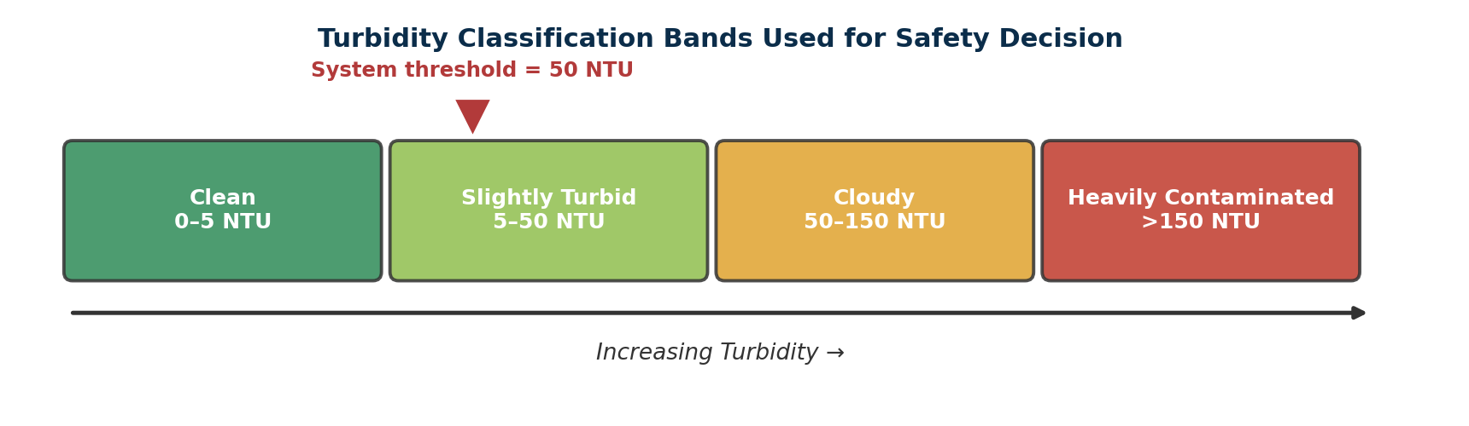
Figure 6.2 — Turbidity Classification Bands and the System Threshold

6.3 Actuators
The current prototype does not include physical actuators such as motors, solenoid valves, or pumps, since the project scope is limited to sensing and reporting rather than actively controlling a water supply. Adding an automatic shut-off valve or an alarm buzzer triggered by an “Unsafe” verdict is identified as a natural extension in Chapter 12. Such an actuator layer would require only a small addition to the existing threshold-comparison logic — the decision point already exists in firmware; only the output device and its driver circuitry would need to be added.

6.4 Display / Output Devices
A 16×2 I2C-based Liquid Crystal Display is the primary local output device. The I2C backpack reduces the wiring needed to drive the LCD from the usual six or more parallel data/control lines down to just two signal lines (SDA and SCL) plus power and ground, simplifying assembly and freeing digital pins for future expansion. The display shows the computed NTU value on the first line and the “Water Safe” / “Water Unsafe” verdict on the second, updating every two seconds. The module uses the standard HD44780-compatible controller with a PCF8574 I/O expander, and responds at I2C address 0x27 (0x3F on some variants).

6.5 Communication Module
The current prototype relies on the Arduino UNO's built-in USB-to-serial interface for communication with a host PC, used for programming the device and viewing live readings on the Serial Monitor during development, testing, and calibration. No wireless communication module such as ESP8266/ESP32 Wi-Fi, HC-05 Bluetooth, or GSM is included in this hardware revision; the system operates as a standalone local-display device. Wireless transmission is discussed as a future enhancement in Chapter 12.

6.6 Power Supply
The complete system — Arduino UNO, turbidity sensor, and I2C LCD — is powered through the Arduino's USB port at a regulated 5 V, drawn either from a computer's USB port or a standard 5 V USB adapter or power bank for field deployment. The Arduino's on-board voltage regulator supplies a stable 5 V rail to both the sensor and the LCD. Total current draw remains well within the roughly 500 mA budget of a standard USB port: approximately 40 mA for the sensor, under 30 mA for the LCD with backlight active, plus the Arduino's own baseline consumption.

6.7 Other Components
The remaining components used in the prototype are:
• Male-to-male and male-to-female jumper wires for all point-to-point connections between the Arduino, sensor, and LCD.
• A USB Type-A to Type-B cable for programming the Arduino and providing power and serial communication.
• A small transparent plastic enclosure housing the assembled electronics, with the sensor probe cable routed out for immersion.
• A drinking glass or sample container used to hold water samples during testing and calibration.

CHAPTER 7

SOFTWARE IMPLEMENTATION

7.1 Software Requirements
The firmware was developed using the Arduino IDE and the following software components:
Table 7.1 — Software Requirements
Software / Library | Version / Purpose
Arduino IDE | 2.3.10 — write, compile, and upload firmware
Wire.h | Built-in — I2C communication library
LiquidCrystal_I2C | 2.3.3 — high-level LCD control interface
Arduino AVR Boards Core | Latest stable — board support package
CH340 / FTDI Driver | USB-to-serial driver for COM port recognition

7.2 Embedded C Program
The complete firmware was written in Embedded C using the Arduino framework. The setup() function initializes the LCD and Serial communication and displays a welcome message; the loop() function continuously reads the turbidity sensor, computes the voltage and estimated NTU, updates both the LCD and Serial Monitor, and repeats with a two-second delay. The full listing is reproduced below and also included in Appendix 14.1.

7.3 Python Program
No Python program was required for the core functionality of this project, since all sensing, computation, and display logic is performed entirely on-board the Arduino UNO in Embedded C. A Python program is therefore not applicable to the current scope. As a future enhancement, a lightweight Python script using the pyserial library could run on the host PC to continuously read the Serial Monitor output and log historical NTU readings to a CSV file or a real-time plot, enabling longer-term trend analysis beyond what the on-board LCD can display.

7.4 Simulation — Wokwi / Raspberry Pi / Thonny (if applicable)
This project was developed and tested directly on physical Arduino UNO hardware rather than through simulation, since a genuine analog turbidity sensor and real water samples were used throughout development, calibration, and testing. Formal circuit simulation using a tool such as Wokwi was therefore not used for the final implementation. Such simulators remain useful for verifying LCD wiring and basic firmware logic before physical assembly, but they cannot reproduce the real optical sensing behaviour of the turbidity probe, which is central to this project.
For this project, the small time saved by simulating LCD wiring separately was judged not worth the extra tooling overhead, since the physical LCD and I2C backpack were already on hand and could be wired and tested directly within minutes. Future iterations that add wireless modules or additional sensors would likely benefit from a simulation pass first, since those additions increase wiring complexity and the risk of a short circuit during physical assembly.

CHAPTER 8

HARDWARE IMPLEMENTATION

8.1 Circuit Assembly
The hardware was assembled by first mounting the Arduino UNO and connecting jumper wires from its 5V, GND, A0, A4 (SDA), and A5 (SCL) pins to the corresponding pins on the turbidity sensor module and the I2C LCD backpack. Care was taken to keep the sensor's signal wire separate from the LCD's I2C lines to minimize interference, and all ground connections were tied to a common reference. Assembly proceeded in a deliberately staged order rather than connecting everything at once: the LCD was wired and verified first, confirming the correct I2C address and readable output, before the turbidity sensor was added — so that any fault could be isolated to the most recently added component.

8.2 Hardware Connections
Table 8.1 documents the exact pin-to-pin wiring used in the final prototype, cross-checked against the firmware's pin definitions before power-on.
Table 8.1 — Hardware Connections
Arduino UNO Pin | Connected To | Purpose
5V | Turbidity Sensor VCC | Sensor power supply
GND | Turbidity Sensor GND | Common ground
A0 | Turbidity Sensor OUT | Analog signal input
A4 (SDA) | LCD SDA | I2C data line
A5 (SCL) | LCD SCL | I2C clock line
5V | LCD VCC | LCD power supply
GND | LCD GND | Common ground

8.3 Prototype Development
Prototype development proceeded in three verified stages. In the first stage the Arduino UNO alone was powered and a blink test confirmed that the board, USB cable, and COM port were all functioning correctly. In the second stage the I2C LCD was added and an I2C address scan confirmed the module responded at 0x27, after which the welcome message from setup() was verified on screen. Only in the third stage was the turbidity sensor connected to A0 and the full firmware uploaded. Figure 8.3 shows the two LCD interface states the completed prototype produces — the safe state when the computed NTU stays at or below the 50 NTU threshold, and the unsafe state when it exceeds it. Keeping the two output states visually distinct and readable at a glance was a deliberate design choice, since the intended user should not need to interpret a raw number to know whether the water is safe.
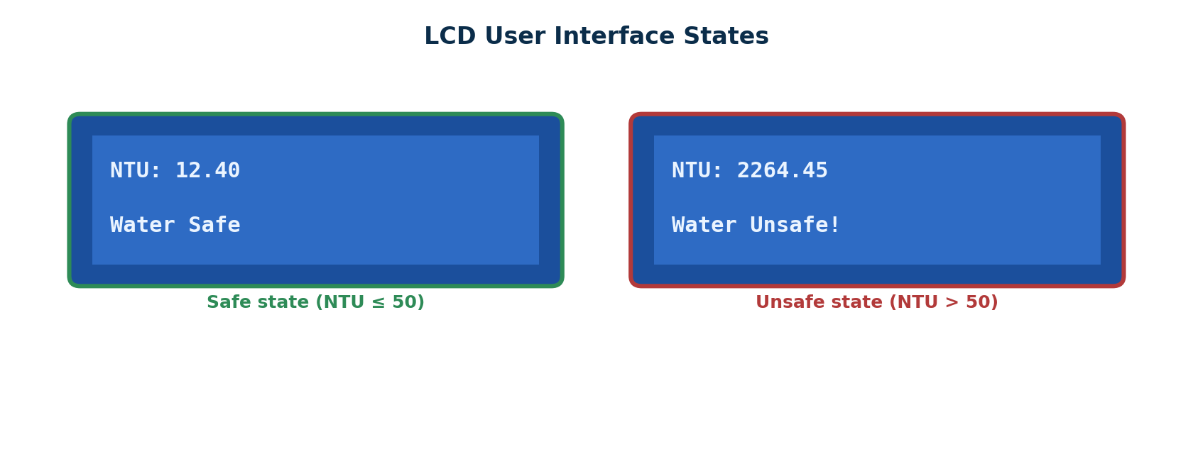
Figure 8.3 — LCD User Interface States Produced by the Prototype

8.4 Working of the Hardware Model
In operation, the turbidity sensor's probe tip is immersed in the water sample under test while the signal-conditioning PCB and the remaining electronics stay outside the water. The Arduino continuously samples the analog output, computes the estimated NTU, and updates the LCD and Serial Monitor every two seconds. The LCD displays the live NTU value on its top row and the corresponding safety verdict on its bottom row, giving an immediate at-a-glance indication without the user needing to view a computer screen once the device is deployed.

8.5 Photographs of the Developed Model
Figure 8.5 shows the fully assembled prototype housed in its enclosure, and Figure 8.5.1 shows a close-up of the LCD during a live test displaying a computed NTU value and the corresponding verdict.
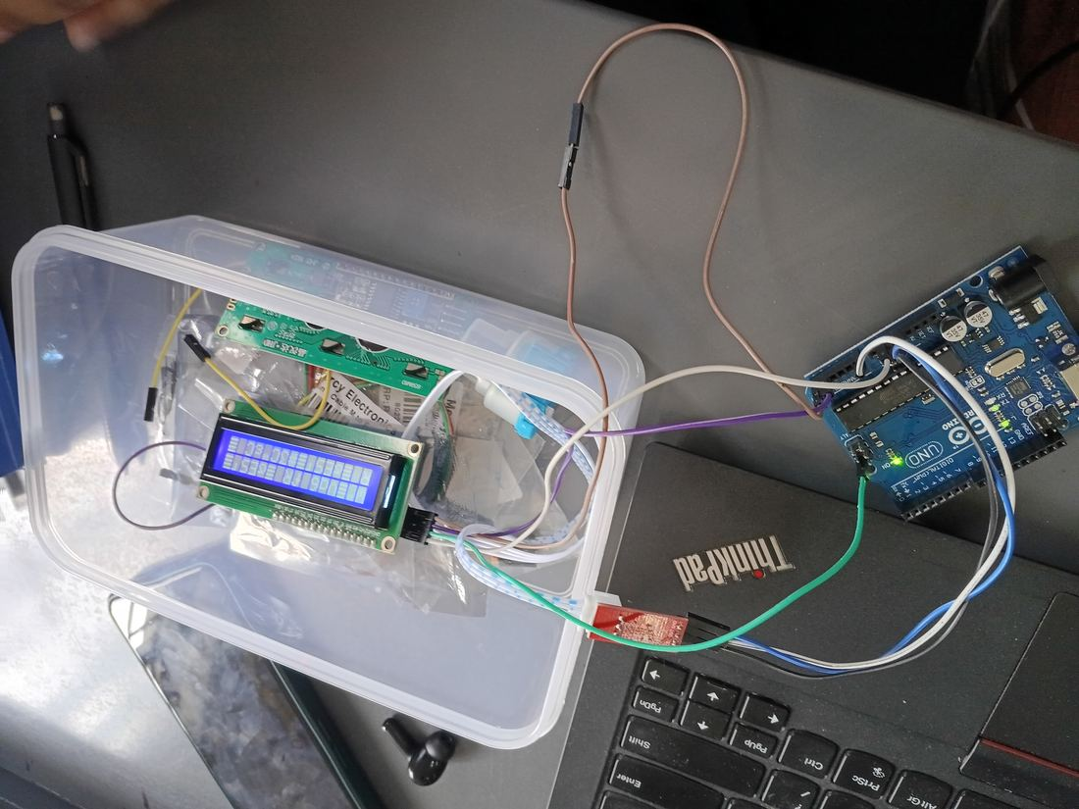
Figure 8.5 — Complete Assembled Prototype
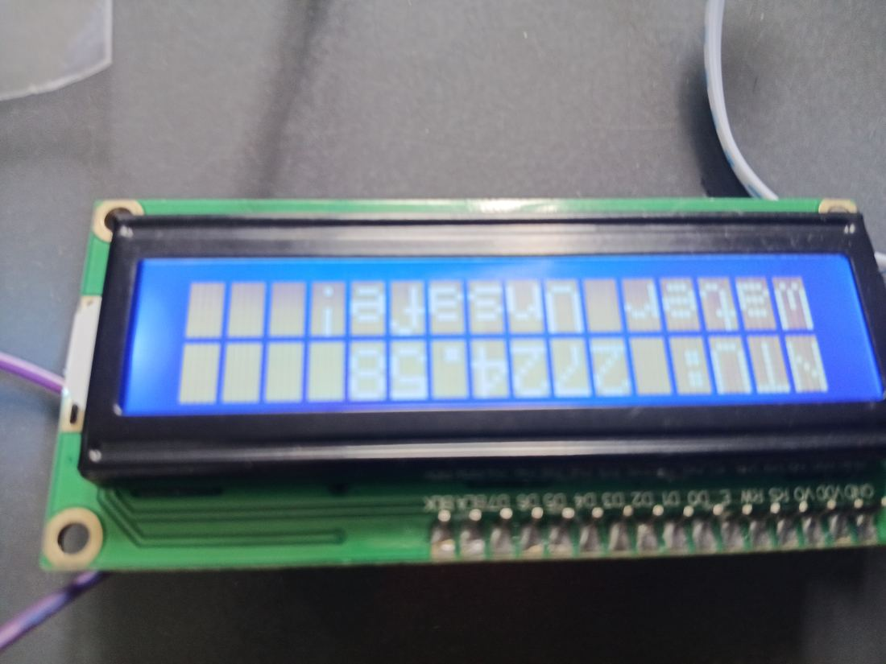
Figure 8.5.1 — LCD Displaying Live NTU Reading and Verdict
The enclosure serves a practical purpose beyond tidiness. Because the probe cable exits through a gap in the side wall, the sensor tip can be lowered into a sample while the Arduino, LCD, and all jumper connections stay dry and undisturbed inside the box. During testing this mattered more than expected — an early attempt with the components loose on the desk resulted in a jumper wire pulling free from A0 mid-reading, which produced a floating-input value that looked like a genuine sensor change until the wiring was re-checked.
The LCD is mounted facing outward through the lid so the reading stays visible without opening the enclosure, and the USB cable exits from the opposite side to keep it clear of the probe cable. The whole assembly is light enough to be carried to a water source in one hand, which was the portability target set out in Chapter 4.

CHAPTER 9

TESTING AND RESULTS

9.1 Testing Procedure
Testing was carried out in two stages. First, the firmware and wiring were verified independently: the LCD was checked for correct I2C address and backlight operation, and the sensor's raw analog readings were monitored on the Serial Monitor to confirm a live, non-zero, stable signal. Second, functional testing was carried out by immersing the sensor probe in a water sample, allowing the reading to stabilize, and recording the raw sensor value, computed voltage, computed NTU, and displayed status across multiple consecutive samples. All tests were conducted indoors at room temperature (25–28°C) using ordinary municipal tap water in a standard drinking glass, with the Arduino powered over USB and the Serial Monitor open at 9600 baud. Each sample was allowed to stabilize for at least two full read cycles (about four seconds) before recording.

9.2 Test Cases
Table 9.2 lists the functional test cases executed and their outcomes.
Table 9.2 — Functional Test Cases
No. | Test Description | Expected Result | Result
1 | Power-on and LCD initialization | Welcome message shown, then cleared | Pass
2 | Serial communication at 9600 baud | Readings printed every 2 seconds | Pass
3 | Sensor analog reading (immersed) | Stable, repeatable voltage | Pass
4 | NTU computation from voltage | NTU computed and clamped to ≥ 0 | Pass
5 | Threshold comparison and verdict | Correct Safe/Unsafe per threshold | Pass
6 | Absolute NTU accuracy (clean water) | NTU near 0 for clean tap water | See §9.5

9.3 Experimental Results
Table 9.3 presents a representative sample of live readings recorded from the Serial Monitor with the probe fully immersed in clean tap water. The voltage was consistently repeatable across successive readings, confirming that the sensor, wiring, and firmware were all functioning correctly and producing a stable signal for an unchanging sample.
Table 9.3 — Experimental Results (Clean Tap Water)
Sample | Raw ADC Value | Voltage (V) | Computed NTU
1 | 346 | 1.69 | 2153.77
2 | 362 | 1.77 | 2299.64
3 | 353 | 1.73 | 2219.27
4 | 369 | 1.80 | 2359.14
5 | 358 | 1.75 | 2264.45
Mean | 357.6 | 1.748 | 2259.25

9.4 Output Screenshot
Figure 9.4 shows a capture of the Arduino IDE Serial Monitor during a live test run, showing the continuously updating Sensor Value, Voltage, computed NTU, and status output produced by the firmware.
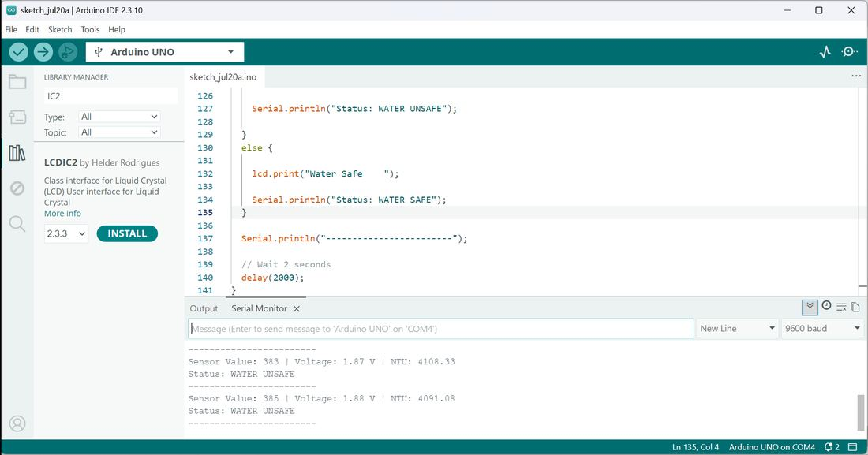
Figure 9.4 — Live Serial Monitor Output During Testing
The same readings are plotted in Figure 9.4.1 to make the stability of the signal easier to assess than a column of printed numbers allows. Both the raw ADC value and the derived voltage stay within a narrow band across all five consecutive samples, with the voltage varying by only 0.11 V end to end. For an unchanging water sample this is the behaviour we would want to see, and it confirms that neither the analog signal path nor the I2C and USB-Serial communication introduced drift or dropped readings during the test run.
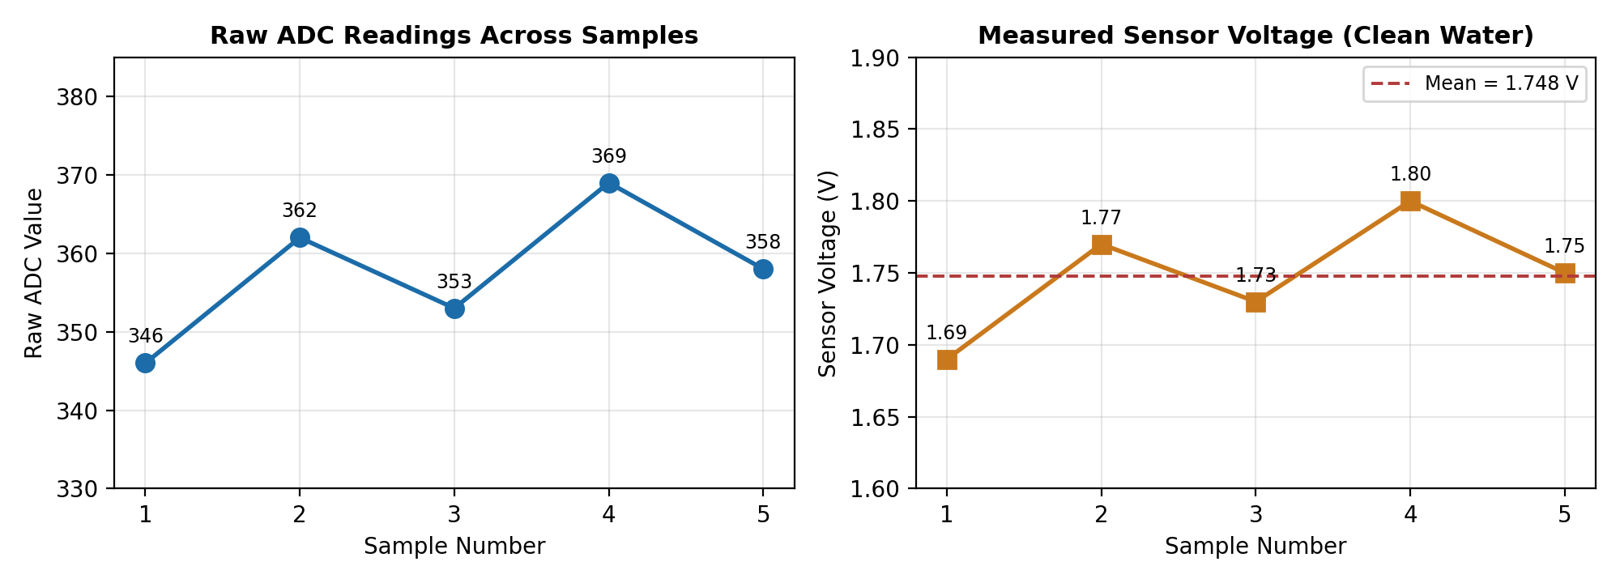
Figure 9.4.1 — Raw ADC Values and Sensor Voltage Across Test Samples

9.5 Performance Analysis
Table 9.5 summarizes the measured performance of the system across the recorded test samples.
Table 9.5 — Performance Analysis
Metric | Observed Value | Remark
Voltage range (clean water) | 1.69 – 1.80 V | Highly repeatable
Voltage std. deviation | ±0.042 V (≈ 2.4%) | Low noise, stable signal
NTU std. deviation | ±78.04 | Follows voltage variation
Update interval | 2 seconds | As designed
LCD / I2C reliability | No faults observed | Stable across all runs
Absolute NTU accuracy | Not achieved | Calibration mismatch — see below
The digital and communication subsystems — LCD initialization, I2C communication, Serial logging, ADC sampling, and threshold logic — performed reliably across every test run with no missed readings or display faults, once the initial upload issue (the Serial Monitor holding the COM port open) was resolved. The one area requiring improvement is the absolute accuracy of the NTU calibration equation for this specific sensor unit. The generic equation used, NTU = −1120.4V² + 5742.3V − 4352.9, assumes a clear-water baseline of approximately 4.0–4.2 V, but this sensor consistently produced 1.69–1.80 V for visibly clean tap water — well below that baseline — causing the computed NTU to read in the thousands and the system to report “Unsafe” under all tested conditions. Wiring was independently re-verified against the firmware pin definitions (Table 8.1) and confirmed correct, isolating the discrepancy to unit-to-unit variation in the sensor's individual response curve rather than a wiring or firmware fault. This finding — that low-cost analog turbidity sensors require sensor-specific two-point calibration rather than a generic published equation — is a genuinely useful outcome of this project's testing phase and is carried forward in Chapter 12.
Figure 9.5 makes the nature of this mismatch clear. The calibration equation is a downward-opening parabola that peaks near 2.5 V and crosses back below the 50 NTU threshold only around 4.2 V. The green band marks where clear water was expected to sit on this curve; the red band marks where our sensor actually operated. Because the measured range of 1.69–1.80 V falls on the steep rising section of the curve rather than near its high-voltage root, every clean-water reading was mapped to a value in the low thousands of NTU. Notably, the two voltages 1.75 V and roughly 3.4 V produce almost the same NTU output on this curve, which means the equation is not even single-valued across the sensor’s full output range — a further reason a unit-specific two-point calibration is required rather than a direct substitution into the published equation.
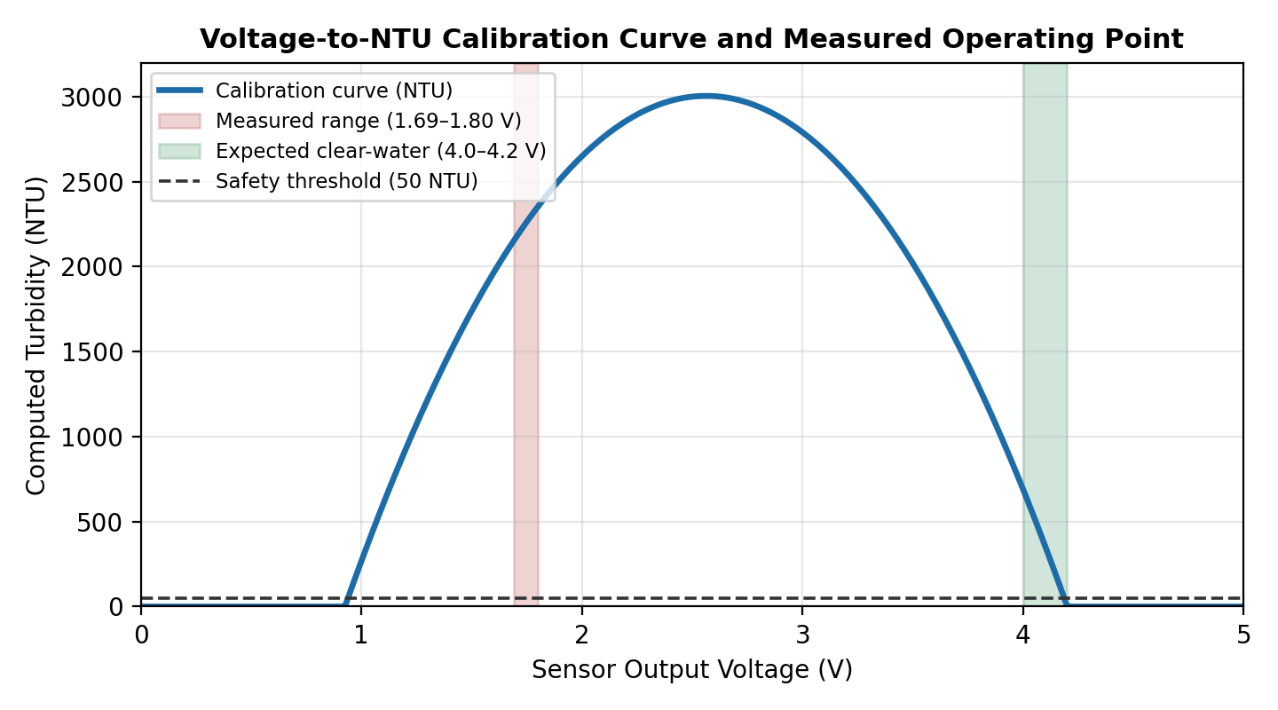
Figure 9.5 — Calibration Curve Showing Expected vs. Measured Operating Range

CHAPTER 10

APPLICATIONS
The low cost, portability, and simplicity of this system make it suitable for a range of real-world applications:
• Household drinking water monitoring — placed near a storage tank or borewell outlet to give residents an ongoing indication of water clarity.
• Small community or school water points — continuous screening at shared sources where laboratory testing is infrequent or unavailable.
• Rainwater harvesting systems — checking collected rainwater for visible contamination before use, especially during the first-flush period after a dry spell.
• Aquaculture and aquarium monitoring — turbidity spikes often precede fish stress or disease outbreaks in tanks and small ponds.
• Educational demonstrations — a hands-on teaching tool for embedded systems, sensor interfacing, and environmental monitoring in school and college laboratories.
• Preliminary field screening — as a first-pass filter to flag samples warranting formal laboratory testing, reducing overall survey cost and turnaround.

CHAPTER 11

ADVANTAGES AND LIMITATIONS
Advantages:
• Very low hardware cost (under ₹1,600) compared to laboratory nephelometers or portable digital meters.
• Provides an immediate, continuous, automatic safety verdict requiring no specialized skill to interpret.
• Uses entirely open-source development tools, avoiding licensing costs and vendor lock-in.
• Compact and portable — the entire prototype fits inside a small handheld enclosure.
• Open, modular design extendable with additional sensors or wireless connectivity without redesigning the core system.
Limitations:
• Absolute NTU accuracy depends on sensor-specific calibration — this unit reads 1.69–1.80 V for clean water against a published curve assuming ~4.0–4.2 V (Section 9.5), so the numeric NTU cannot be trusted until calibrated.
• Measures turbidity only — cannot detect chemical contaminants, dissolved oxygen, pH imbalance, or microbiological hazards. A “Safe” verdict means “no visible particulate matter,” not full potability.
• No on-board battery; requires a wired USB power source, ruling out untethered field deployment.
• No historical data logging — readings exist only on the live LCD/Serial session and are lost once powered off.
• Sensor waterproofing is limited to its marked immersion line; prolonged or aggressive-chemical exposure risks damaging the electronics.
• The 16×2 LCD shows only 32 characters at once, leaving no room for a timestamp or trend indicator without cycling screens.
• A single fixed 50 NTU threshold gives a binary verdict, not graded severity — marginal and severe contamination look identical on screen.
• Tested only with tap water at room temperature over short runs; behaviour with muddy samples, temperature extremes, or long-term operation is unverified.

CHAPTER 12

CONCLUSION AND FUTURE SCOPE
This project successfully designed, implemented, and tested a low-cost standalone embedded water quality monitoring system built around an Arduino UNO, an analog turbidity sensor, and a 16×2 I2C LCD. The complete hardware–software pipeline — analog sensing, ADC sampling, voltage-to-NTU conversion, threshold-based classification, and dual-channel output — was implemented in Embedded C and verified through hands-on assembly and functional testing. All digital subsystems performed reliably throughout testing. The testing phase also surfaced a genuinely valuable practical finding: the specific sensor unit required individual on-site calibration rather than a generic published equation, underscoring an important real-world lesson in working with low-cost analog sensors. Overall, the project demonstrates that a functional, real-time, easy-to-interpret water-quality screening tool can be built from inexpensive, widely available components.
Future Scope:
• Perform a two-point (clean-water / turbid-water) on-site calibration to derive a custom voltage-to-NTU equation matched to the deployed sensor unit.
• Add wireless connectivity (ESP8266/ESP32) to transmit readings to a cloud dashboard or mobile application for remote monitoring.
• Integrate additional sensors — pH, TDS, and temperature — for a more complete multi-parameter water-quality assessment.
• Add on-board data logging via an SD card module to record long-term history without a continuous PC connection.
• Incorporate a rechargeable battery and power management to enable fully untethered portable field deployment.
• Add an audible buzzer or visual LED alarm triggered automatically by an “Unsafe” verdict for cases where the user is not watching the LCD.
• Explore graded severity levels (e.g. clean / slightly turbid / cloudy / heavily contaminated) instead of a single binary threshold, following the banding approach of Bankar et al. [2].

CHAPTER 13

REFERENCES
S.No. | Reference | Description
1 | S. Kori and Rajashekarappa, “Measurement of Turbidity Using Light Scattering,” Int. Conf. on Sensors and Instrumentation, 2022. | Establishes the light-scattering/attenuation principle used to relate suspended particles to sensor output — the core sensing concept behind this project.
2 | S. Bankar et al., “Arduino-based Water Quality Monitoring System Using Turbidity Sensor,” Journal of Water Pollution & Purification Research, 2026. | Classifies water into four turbidity bands (clean/slightly dirty/cloudy/contaminated); informed the banding diagram in Fig. 6.2 of this report.
3 | M. Ramadhan, R. Hidayat et al., “Arduino Uno-based Water Turbidity Meter Using LDR and LED Sensors,” Journal of Physics: Conf. Series, 2020. | Demonstrates the same IR-LED/phototransistor + Arduino UNO + LCD hardware combination used in this prototype, confirming its feasibility.
4 | S. Mukta et al., “IoT Based Smart Water Quality Monitoring System,” IEEE Conf. Publication / ScienceDirect, 2021. | Multi-sensor (pH, temperature, turbidity, conductivity) Arduino system; reviewed to compare single- vs. multi-parameter design trade-offs (Ch. 2).
5 | “An Arduino-based Water Quality Monitoring System Using pH, Temperature, Turbidity, and TDS Sensors,” ResearchGate, 2023. | Two-node (sensor + sink) architecture with buzzer alerting; referenced when designing this project's own Safe/Unsafe alert logic.
6 | P. Chettri, “IoT Based Water Quality Monitoring System Using Arduino Uno R3 & NodeMCU ESP8266,” ResearchGate, 2023. | Adds cloud connectivity and K-Means clustering on top of Arduino sensing; cited in the Future Scope discussion on wireless extension (Ch. 12).
7 | “Development of Water Quality Monitoring Device Using Arduino UNO (Kolora Meter),” IOPscience, 2021. | Low-cost Arduino + NodeMCU turbidity/temperature device; supports the cost-comparison figures used in Table 6.2 (Bill of Materials).
8 | “Design and Implementation of a Smart Water Monitoring System (IoT) Using Arduino Microcontroller,” ResearchGate, 2022. | Combines water-level and quality sensing with an Android app; reviewed for the wireless/app-based future-scope recommendation.
9 | “IoT-Based Water Quality Monitoring System in Philippine Off-Grid Communities,” arXiv:2410.14619, 2024. | Field deployment of a low-cost Arduino system in a rural, off-grid setting — closely matches this project's target use case (Ch. 10, Applications).
10 | “WASD — Water Saving Device,” arXiv:2409.09798, 2024. | Reviews several 3–4-sensor Arduino/NodeMCU water-monitoring designs; used to benchmark this project's deliberately minimal single-sensor scope.
11 | DFRobot, “Turbidity Sensor SKU: SEN0189 — Wiki and Datasheet,” wiki.dfrobot.com. | Manufacturer reference for the analog turbidity sensor module used in this project, including its default voltage-to-NTU calibration curve.
12 | Arduino, “Arduino UNO Rev3 Product Reference,” docs.arduino.cc. | Official pin-out, electrical, and memory specifications for the ATmega328P-based board used as the project's microcontroller.
13 | F. Malpartida / J. Rickman, “LiquidCrystal_I2C Library for Arduino,” GitHub Repository. | Open-source library providing the init(), backlight(), and print() functions used to drive the 16×2 I2C LCD in the firmware (Ch. 7).
14 | United States EPA, “Method 180.1: Determination of Turbidity by Nephelometry,” Rev. 2.0, 1993. | Defines the standardized 90° nephelometric method that NTU as a unit is based on, providing the scientific basis for Chapter 5's working principle.
15 | World Health Organization, “Guidelines for Drinking-water Quality,” 4th Edition, WHO, Geneva. | International reference for turbidity and potability guidance, used to justify the 50 NTU safety threshold chosen for this system.
16 | Bureau of Indian Standards, “IS 10500:2012 — Drinking Water Specification (2nd Revision),” BIS, New Delhi. | Indian national standard specifying acceptable (1 NTU) and permissible (5 NTU) turbidity limits, relevant to future threshold tuning for local deployment.
17 | Arduino, “analogRead() Function Reference,” docs.arduino.cc/language-reference. | Official documentation for the 10-bit ADC function used to sample the turbidity sensor's analog output on pin A0.
18 | Hitachi, “HD44780U (LCD-II) Dot Matrix Liquid Crystal Display Controller/Driver Datasheet.” | Underlying controller datasheet for the 16×2 character LCD, describing the 4-bit parallel interface wrapped by the I2C backpack used in this project.
19 | NXP Semiconductors, “PCF8574 Remote 8-bit I/O Expander for I2C-bus Datasheet.” | Datasheet for the I/O expander chip on the LCD's I2C backpack that converts the parallel LCD interface into the two-wire SDA/SCL connection used here.
20 | NXP Semiconductors, “I2C-bus Specification and User Manual,” Rev. 6. | Defines the I2C protocol timing and addressing rules (including the 0x27 default address) that govern communication with the LCD module.

CHAPTER 14

APPENDIX
A.1 Full Source Code — the complete Embedded C firmware (sketch.ino) used to program the Arduino UNO is reproduced below; a copy is also available at [GitHub/Colab link].
#include <Wire.h>
#include <LiquidCrystal_I2C.h>

LiquidCrystal_I2C lcd(0x27, 16, 2);
const int turbiditySensorPin = A0;
const float thresholdNTU = 50.0;

void setup() {
lcd.init();
lcd.backlight();
Serial.begin(9600);
lcd.setCursor(0, 0); lcd.print("Water Quality");
lcd.setCursor(0, 1); lcd.print("Initializing...");
delay(2000);
lcd.clear();
Serial.println("Water Quality Monitoring");
}

void loop() {
int sensorValue = analogRead(turbiditySensorPin);
float voltage = sensorValue * (5.0 / 1023.0);
float ntu = -1120.4 * square(voltage)
+ 5742.3 * voltage - 4352.9;
if (ntu < 0) { ntu = 0; }

Serial.print("Sensor Value: "); Serial.print(sensorValue);
Serial.print(" | Voltage: "); Serial.print(voltage, 2);
Serial.print(" V | NTU: "); Serial.println(ntu, 2);

lcd.setCursor(0, 0);
lcd.print("NTU: "); lcd.print(ntu, 2); lcd.print(" ");
lcd.setCursor(0, 1);
if (ntu > thresholdNTU) {
lcd.print("Water Unsafe! ");
Serial.println("Status: WATER UNSAFE");
} else {
lcd.print("Water Safe ");
Serial.println("Status: WATER SAFE");
}
delay(2000);
}
A.2 Complete weekly PBL log and mentor sign-offs are maintained separately and available on request.

A.3 Self and Peer Assessment
Team Member | Self-Rated Contribution (%) | Peer-Rated Contribution (%) | Remarks
Harshini T V | [%] | [%] | [remarks]
Harini R | [%] | [%] | [remarks]
#include <Wire.h>
#include <LiquidCrystal_I2C.h>

LiquidCrystal_I2C lcd(0x27, 16, 2);
const int turbiditySensorPin = A0;
const float thresholdNTU = 50.0;

void setup() {
lcd.init();
lcd.backlight();
Serial.begin(9600);
lcd.setCursor(0, 0); lcd.print("Water Quality");
lcd.setCursor(0, 1); lcd.print("Initializing...");
delay(2000);
lcd.clear();
Serial.println("Water Quality Monitoring");
}

void loop() {
int sensorValue = analogRead(turbiditySensorPin);
float voltage = sensorValue * (5.0 / 1023.0);
float ntu = -1120.4 * square(voltage)
+ 5742.3 * voltage - 4352.9;
if (ntu < 0) { ntu = 0; }

Serial.print("Sensor Value: "); Serial.print(sensorValue);
Serial.print(" | Voltage: "); Serial.print(voltage, 2);
Serial.print(" V | NTU: "); Serial.println(ntu, 2);

lcd.setCursor(0, 0);
lcd.print("NTU: "); lcd.print(ntu, 2); lcd.print(" ");
lcd.setCursor(0, 1);
if (ntu > thresholdNTU) {
lcd.print("Water Unsafe! ");
Serial.println("Status: WATER UNSAFE");
} else {
lcd.print("Water Safe ");
Serial.println("Status: WATER SAFE");
}
delay(2000);
}

